  
  
  
**Parallel and Distributed Computing  
CSE4001**

***Lab Assignment 3***

Slot : L21+L22

Name : Kulvir Singh

Register Number : 19BCE2074

**Question 1 : OpenMP programs for demonstrating conditional construct**

***AIM and PROCEDURE :***

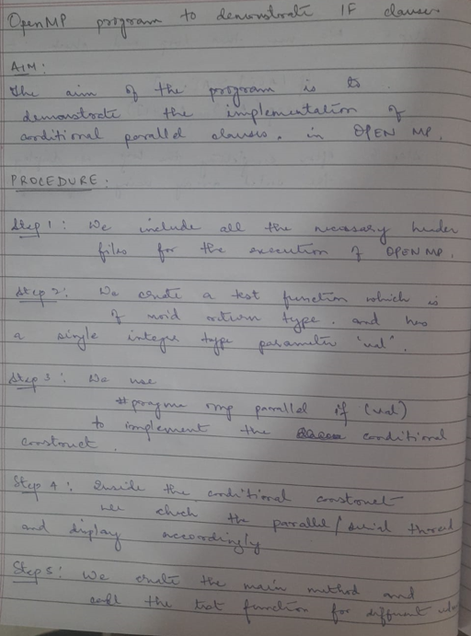

Code Screenshot

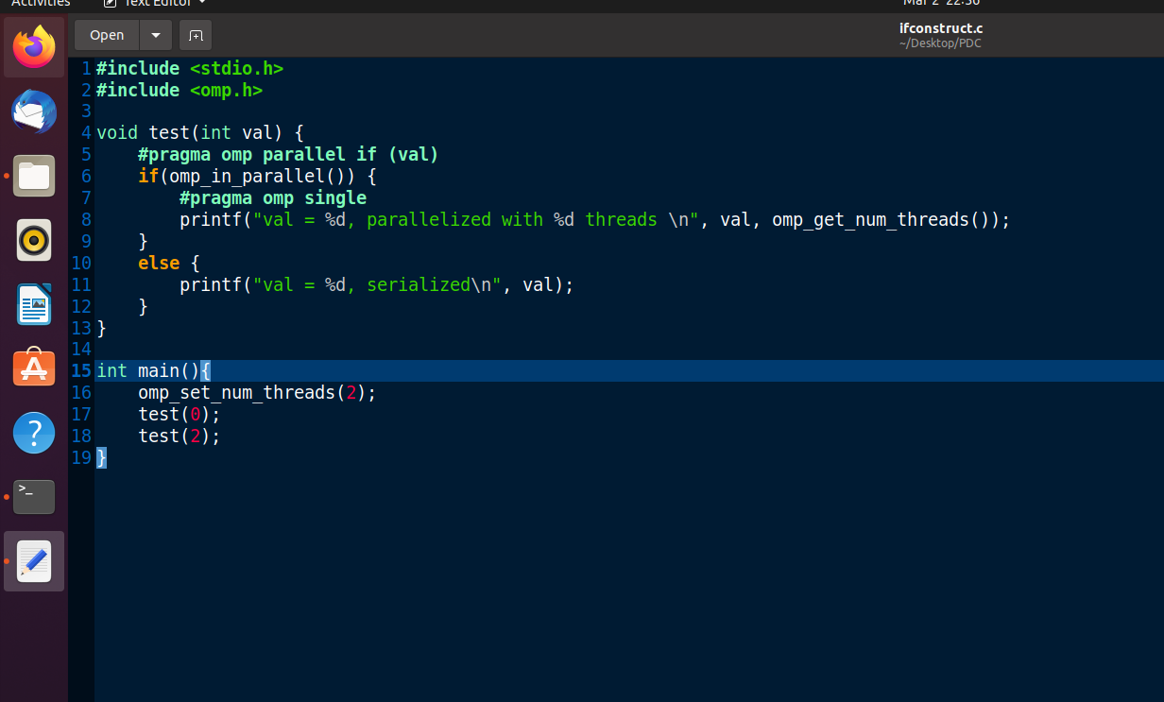

OUTPUT SCREENSHOT

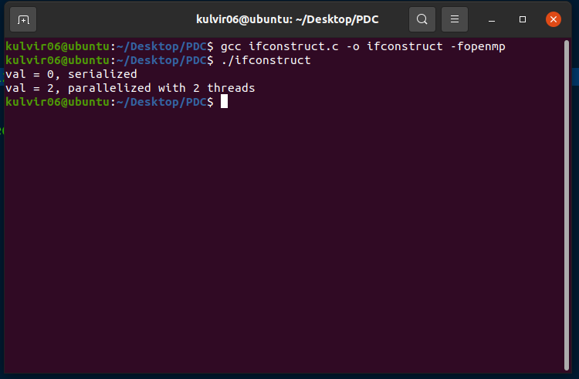

**Conclusion :**

The code demonstrates that when 0 is passed to test function, 0 threads are initiated as it fails the if clause of #pragma omp and 2 threads are created in parallel when 2 is passed to the test function

**Question 2 : OpenMP programs for demonstrating scope of data attributes (first and last private)**

***AIM and PROCEDURE :***

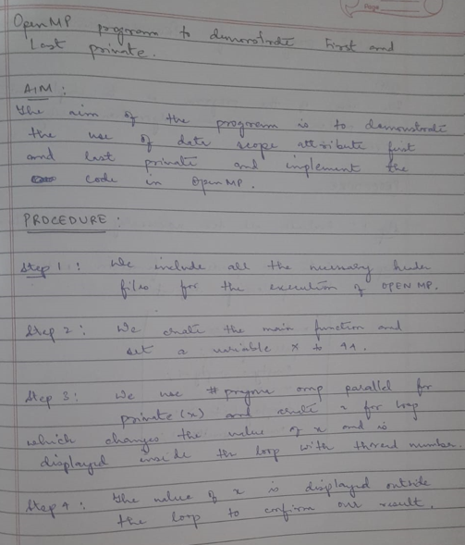

Code Screenshot

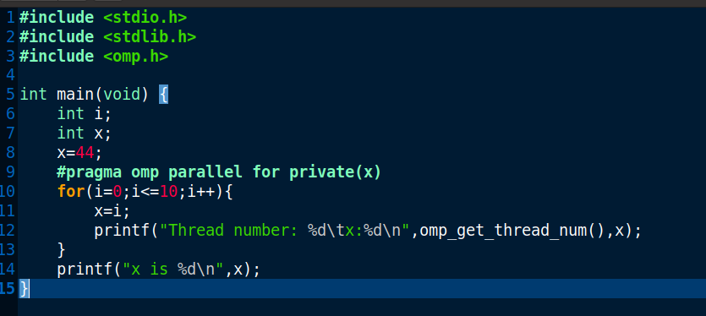

OUTPUT SCREENSHOT

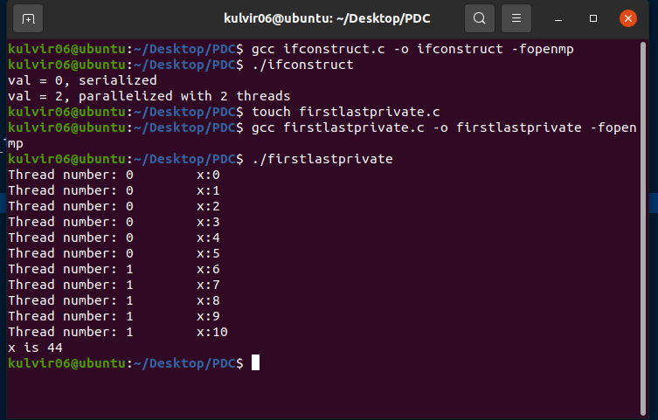

**Conclusion :**

The code demonstrates that when x is initialized as 44 and is set as private for the #pragma omp, for the threads the values of x change but for outside the thread the value is still 44 hence first and last private is cleared.

**Question 3 : OpenMP program for demonstrating BUBBLE SORT ALGORITHM**

***AIM and PROCEDURE :***

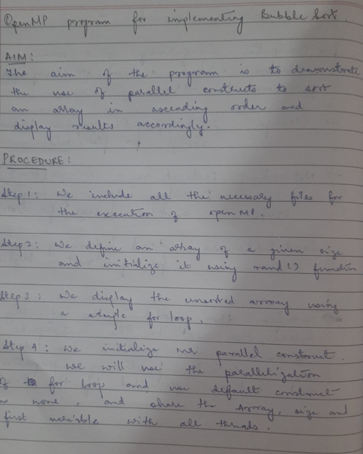

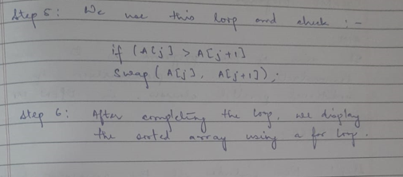

Code Screenshot

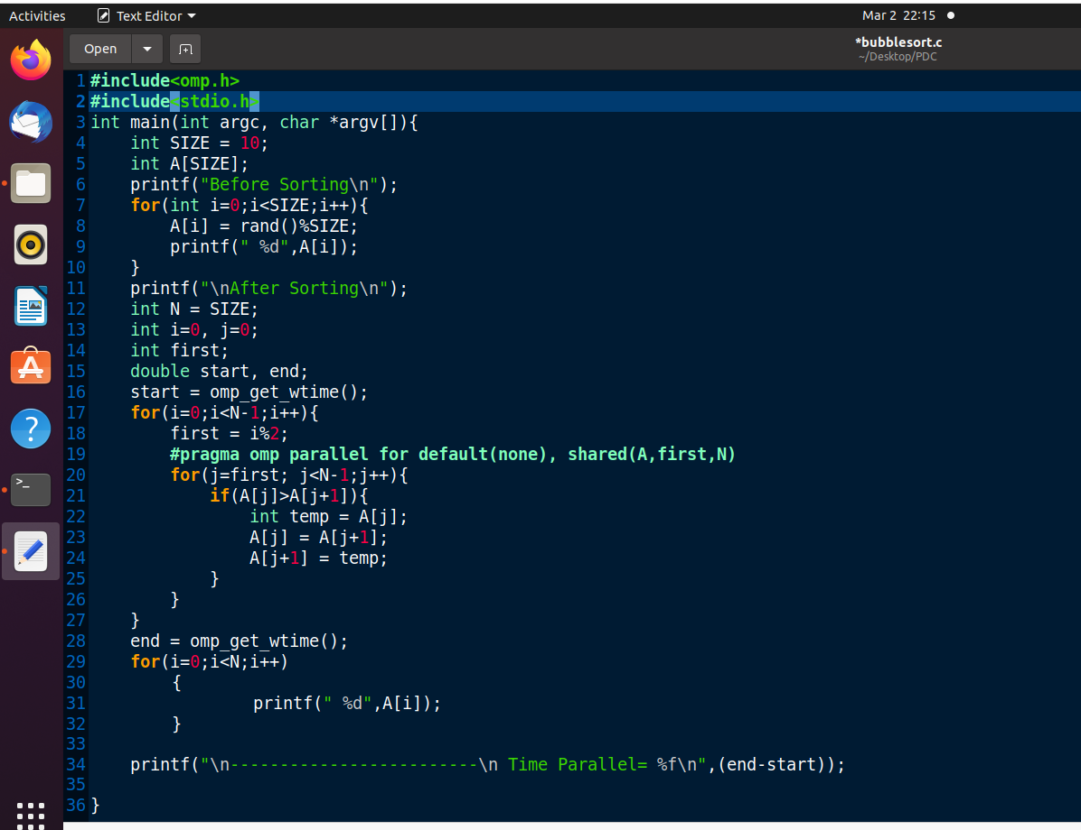

OUTPUT SCREENSHOT

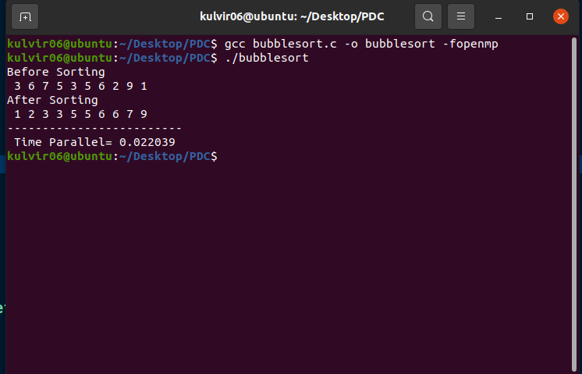

**Conclusion :**

The code successfully sorts the array in ascending order using bubble sort and openmp